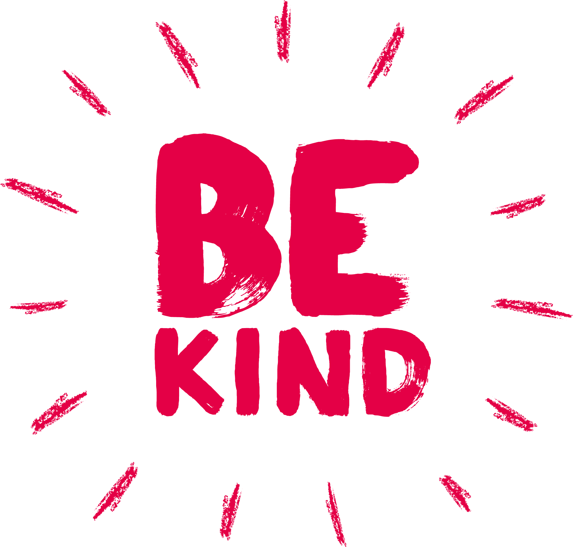Please “Be kind” to our staff. A simple thank you, or a positive review could make the world of difference.

Send any comments and feedback to email:[roccg.swallownestcarecoordinators@nhs.net](mailto:roccg.swallownestcarecoordinators@nhs.net)

We will be closed from 12.00pm for training on Thursday 12th December 2024.



Wishing all our patients a merry Christmas and a Healthy new year!

**Please remember to order your prescriptions on time over the Christmas and new year period.**

**The surgery will be closed Wednesday 25th and Thursday 26th December 2024 and Wednesday 1st January 2025.**

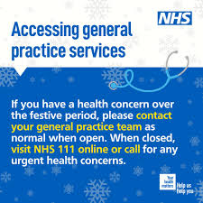

fied, Rotherham, Doncaster, Barnsley, or Bassetlaw.

* If you are aged 18 and over.
* If you have a physical and/or mental health condition.
* If you are unemployed and looking for work.
* If you are working and want support to continue working.
* If you are off work sick and want to return to work.
* If you live in Sheffield, Rotherham, Doncaster, Barnsley, or Bassetlaw.
* If you are aged 18 and over.
* If you have a physical and/or mental health condition.
* If you are unemployed and looking for work.
* If you are working and want support to continue working.
* If you are off work sick and want to return to work.

Monthly Newsletter

December 2024

***

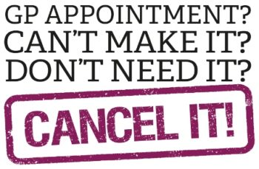

**DNA’s November Breakdown**

**208 patients did not attend their appointments last month November 2024**

**That’s 7% of appointments which has de-creased by 3% since last month.**

**Here is the Breakdown of some appointments that were missed.**

* **ANP - 1**
* **GP appointments – 48**
* **Nurse appointments – 94**
* **HCA (blood/BP /other clinics) - 53**
* **Flu clinics – finished now**
* **Pharmacist – 5**
* **Paramedic - 4**
* **Physician Associate – 3**

**Appointments are valuable, and it's important that if you can't attend to let us know in plenty of time.**

**Did you know that the average cost of a GP appointment in the UK is £42?**

**To cancel an appointment please use the following options to allow someone else to use it.**

**call us on 0114 433 3888 the following options appear: -**

**Press 1 to cancel your appointment via an auto attendant.**

**Advisor if you also need to rebook.**

**You can also cancel by emailing** [**syicb-rotherham.swallownestnoreply@nhs.net**](mailto:syicb-rotherham.swallownestnoreply@nhs.net)



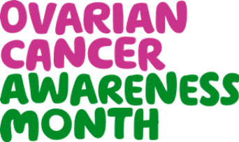

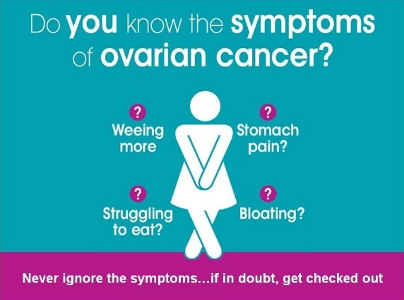

Ovarian cancer is when abnormal cells in the ovary begin to grow and divide in an uncontrolled way. And eventually form a growth (tumour). If not caught early, cancer cells gradually grow into the surrounding tissues. They may spread to other areas of the body. There are different types of ovarian cancer. The type of ovarian cancer you have depends on the type of cell it starts in. Around 7,500 women are diagnosed with ovarian cancer in the UK each year. This makes ovarian cancer the 6th most common cancer in women. Ovarian cancer can affect women, some transgender men and non-binary people assigned female at birth. Your risk of developing ovarian cancer increases as you get older. The risk is greatest in those aged between 75 and 79. We don't know exactly what causes epithelial ovarian cancer. But some factors may increase or reduce the risk.

You should arrange to see your doctor if you have any of these signs and symptoms:

* feeling full quickly
* loss of appetite
* pain in your tummy (abdomen) or lower part of your abdomen that does not go away.
* bloating or an increase in the size of your abdomen
* needing to wee more often

You may also have these other symptoms:

* tiredness that is unexplained
* weight loss that is unexplained
* changes in your bowel habit or symptoms of irritable bowel syndrome, especially if this starts after the age of 50.

These are all symptoms of other less serious conditions but if you have them or anything else that is not normal for you get them checked out by your doctor.

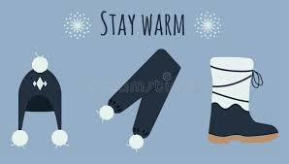

**Keeping warm in winter** 

* **Heat your home to at least 18°C (65°F).** You might prefer your main living room to be slightly warmer.
* **Keep your bedroom window closed on winter nights.** Breathing chilly air can be bad for your health as it increases the risk of chest infections.
* **Keep active when you are indoors.** Try not to sit still for more than an hour or so.
* **Wear several layers of light clothes.** Several layers trap warm air better than one bulky layer.
* **Food is a vital source of energy** and helps to keep your body  
  warm so have plenty of hot food and drinks.
* **Keeping well** will allow you to do more and keep your independence. Being cold is not just uncomfortable it can be bad for your health. Sitting or sleeping in a cold room is not good for you and increases the risk of heart attacks, stroke, and breathing problems.
* **Don’t let the cold catch you out**, check the weather forecast and be ready for cold weather.
* **Wear shoes with a good grip**to prevent slips and falls.
* 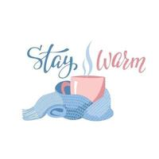**Enquire about medication delivery services** in case you are unable to go out.