***

Please “Be kind” to our staff. A simple thank you, or a positive review could make the world of difference.

Send any comments and feedback to email:[roccg.swallownestcarecoordinators@nhs.net](mailto:roccg.swallownestcarecoordinators@nhs.net)

We will be closed from 12.00pm for training on Thursday 14th November 2024.

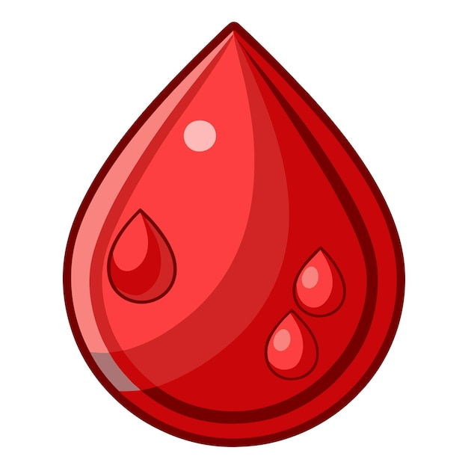Blood Appointments

As of new guidelines we are no longer able to undertake hospital bloods. The only blood appointments we can offer here at the surgery are requests made in primary care. Hospital bloods request by letter will no longer be accepted.

We have been informed that hospitals are no longer undertaking our blood requests for adults the only exception is children under 12.



**The PPG had their AGM meeting on Thursday 17th October 2024. Thank you for everyone who attended it was great to see some new faces. At the AGM a new chair and vice chair were appointed. The PPG would like to encourage a diverse membership of age and ability to join. Members must be over 18 years of age. Meetings are approximately 6 times a year. To join please contact the Health Centre or visit our website** [Contacts – Swallownest Health Centre](https://swallownesthealthcentre.co.uk/contacts/) .

fied, Rotherham, Doncaster, Barnsley, or Bassetlaw.

* If you are aged 18 and over.
* If you have a physical and/or mental health condition.
* If you are unemployed and looking for work.
* If you are working and want support to continue working.
* If you are off work sick and want to return to work.
* If you live in Sheffield, Rotherham, Doncaster, Barnsley, or Bassetlaw.
* If you are aged 18 and over.
* If you have a physical and/or mental health condition.
* If you are unemployed and looking for work.
* If you are working and want support to continue working.
* If you are off work sick and want to return to work.

Monthly Newsletter

November 2024

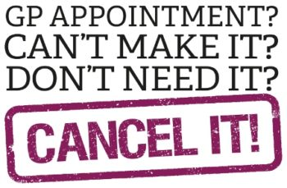

**DNA’s October Breakdown**

**472 patients did not attend their appointments last month August 2024**

**That’s 11% of appointments which has increased by 7% since last month.**

**Here’s the Breakdown of some appointments that were missed**

* **ANP - 2**
* **GP appointments – 62**
* **Nurse appointments – 22**
* **HCA (blood/BP /other clinics) - 51**
* **Flu clinics – 171**
* **Pharmacist – 6**
* **Misc – 77**
* **Nasal Flu vaccine - 7**

**Appointments are valuable, and it's important that if you can't attend to let us know in plenty of time.**

**Did you know that the average cost of a GP appointment in the UK is £42?**

**To cancel an appointment please use the following options to allow someone else to use it.**

**call us on 0114 433 3888 the following options appear: -**

**Press 1 to cancel your appointment via an auto attendant.**

**Press 2 to speak to a Patient Services Advisor if you also need to rebook.**

**You can also cancel by emailing** [**syicb-rotherham.swallownestnoreply@nhs.net**](mailto:syicb-rotherham.swallownestnoreply@nhs.net)

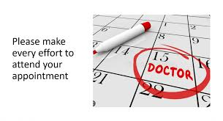

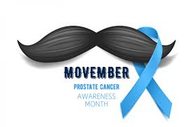**Prostate cancer usually develops slowly, so there may be no signs for many years.**

**Symptoms of prostate cancer**

Symptoms of prostate cancer do not usually appear until the prostate is large enough to affect the tube that carries urine from the bladder out of the penis (urethra).

When this happens, you may notice things like:

an increased need to pee

straining while you pee

a feeling that your bladder has not fully emptied

These symptoms should not be ignored, but they do not mean you have prostate cancer.

It's more likely they're caused by something else, such as [prostate enlargement](https://www.nhs.uk/conditions/prostate-enlargement/)

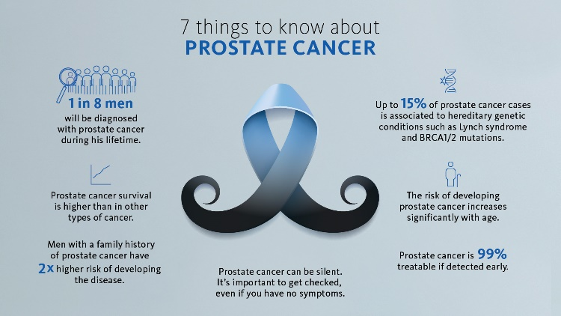

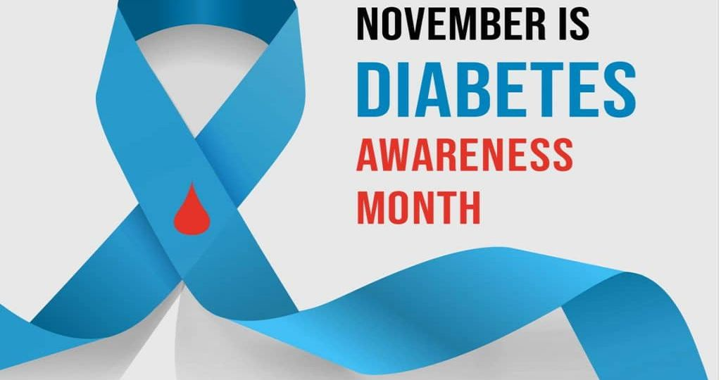

**Diabetes is a condition that causes a person's blood sugar level to become too high.**

There are 2 main types of diabetes:

[Type 1 diabetes](https://www.nhs.uk/conditions/type-1-diabetes/) – a lifelong condition where the body's immune system attacks and destroys the cells that produce insulin

[type 2 diabetes](https://www.nhs.uk/conditions/type-2-diabetes/) – where the body does not produce enough insulin, or the body's cells do not react to insulin properly

Type 2 diabetes is far more common than type 1. In the UK, over 90% of all adults with diabetes have type 2.

High blood sugar that develops during pregnancy is known as [gestational diabetes](https://www.nhs.uk/conditions/gestational-diabetes/). It usually goes away after giving birth.

Visit your GP as soon as possible if you experience the main symptoms of diabetes, which include:

feeling very [thirsty](https://www.nhs.uk/conditions/thirst/), peeing more frequently than usual, particularly at night, feeling very tired, weight loss and loss of muscle bulk, itching around the penis or vagina, or frequent episodes of [thrush](https://www.nhs.uk/conditions/thrush-in-men-and-women/), blurred vision

Type 1 diabetes can develop quickly over weeks or even days. Weight loss is common in people with type 1 diabetes when it first develops and before it's treated, but it's less common in people with type 2 diabetes.

Many people have type 2 diabetes for years without realising because the early symptoms tend to be general, or there are no symptoms at all.