Swallownest Health Centre

Please “Be kind” to our staff. A simple thank you, or a positive review could make the world of difference.

Email: [roccg.swallownestcarecoordinators@nhs.net](mailto:roccg.swallownestcarecoordinators@nhs.net)

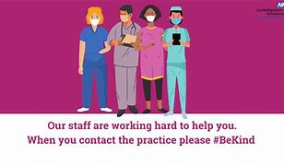**Bright Sky**

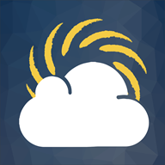Bright Sky is a free to download mobile app providing support and information for anyone who may be in an abusive relationship or those concerned about someone they know.

The app is also available to use in Polish, Punjabi and Urdu.

For more information, please see details and advice about using the app in your app store:

* [Bright Sky in Apple Store](https://apps.apple.com/gb/app/bright-sky/id1105880511)
* [Bright Sky in Google Play](https://play.google.com/store/apps/details?id=com.newtonmobile.hestia)

Further Bright Sky support is also available under our [Support Now](https://www.england.nhs.uk/supporting-our-nhs-people/support-now/) section titled ‘[Finding calm amongst the chaos](https://www.england.nhs.uk/supporting-our-nhs-people/support-now/wellbeing-apps/bright-sky/calm-amongst-chaos/)‘.

* If you live in Sheffield, Rotherham, Doncaster, Barnsley, or Bassetlaw.
* If you are aged 18 and over.
* If you have a physical and/or mental health condition.
* If you are unemployed and looking for work.
* If you are working and want support to continue working.
* If you are off work sick and want to return to work.
* If you live in Sheffield, Rotherham, Doncaster, Barnsley, or Bassetlaw.
* If you are aged 18 and over.
* If you have a physical and/or mental health condition.
* If you are unemployed and looking for work.
* If you are working and want support to continue working.
* If you are off work sick and want to return to work.

Monthly Newsletter

June 2022



**Friendship services**

At Age UK, one of the ways we try to combat loneliness in later life is through our friendship services.

We offer 2 different types:

* Telephone friendship
* Face to face befriending

Please click on the link below to access information.

<https://www.ageuk.org.uk/services/befriending-services/>

Age UK Local Group

Swallownest Chatterbox -Swallownest Central Methodist Church Tuesdays 10.30-12.30

Age UK Rotherham - 01709 835 214

Spring clean your health with Healthy Rotherham [Spring Health – Healthy Rotherham (yourhealthrotherham.co.uk)](https://yourhealthrotherham.co.uk/spring-health/)

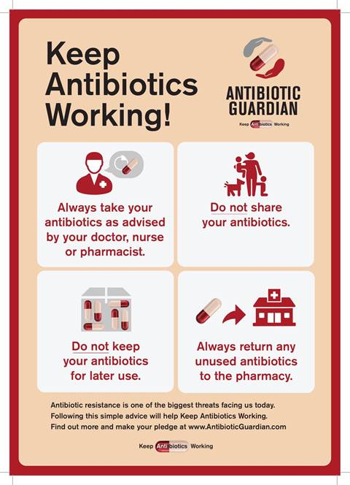

|  |  |  |
| --- | --- | --- |
|  |  |  |
|  |  |  |
|  |  |  |

WHO CAN ACCESS AN APPOINTMENT WITH A FIRST CONTACT PHYSIOTHERAPIST?

An appointment can be access by patients over the age of 16 registered with a Rotherham GP practice with a probable MSK complaint.

Exclusion criteria:

* Under 16 years of age
* Feeling generally unwell
* Open wounds
* Abdominal pain
* Chest pain
* Symptoms that are not felt to be originating from a muscle/joint or nerve problem.

Inclusion criteria:

* Back pain
* Neck pain
* Spinal pain
* Shoulder pain
* Pain in the elbow, wrist or hand
* Pain in the hip, knee or ankle
* Muscular sprain or strain

HOW TO ACCESS APPOINTMENTS WITH FIRST CONTACT PHYSIOTHERAPY

Patients can access an appointment via two methods:

1. Ring their own GP practice where the appropriately trained care navigator will be able to book an appointment.
2. Book an appointment via the [**Rotherham Health app**](https://connecthealthcarerotherham.co.uk/index.php/rotherham-health-app/).

Have you got a nominated a Pharmacy on your records?

Save time when collecting your medication by having your prescription sent electronically to your pharmacy. You can update this on the Rotherham Health App or email us [roccg.swallownestreception@nhs.net](mailto:roccg.swallownestreception@nhs.net)

Get a prescription prepayment certificate

You can buy prescription prepayment certificates (PPCs) from the NHS which may make your prescriptions cheaper.

£30.25 for 3 months

£108.10 for 12 months

[Get a prescription prepayment certificate - GOV.UK (www.gov.uk)](https://www.gov.uk/get-a-ppc)

<https://sheffieldurgentcare.co.uk/>

