Swallownest Health Centre 

Please “*Be kind*” to our staff. A simple thank you, or a written compliment/positive review could make the world of difference to someones day.

Email: [roccg.swallownestcarecoordinators@nhs.net](mailto:roccg.swallownestcarecoordinators@nhs.net)



Working Win supports people who have a health condition to find and stay in employment. If you’re looking for a new role, or struggling at work, sign up for our free support. We’ll work with you to build on your strengths, and to feel settled and flourish in your role.

**Who is Working Win for?**

* If you live in Sheffield, Rotherham, Doncaster, Barnsley, or Bassetlaw.
* If you are aged 18 and over.
* If you have a physical and/or mental health condition.
* If you are unemployed and looking for work.
* If you are working and want support to continue working.
* If you are off work sick and want to return to work.

**Confidence in the Menopause**

This is aimed at any healthcare professional who sees women and who would like to formalise and accredit their learning and consulting skills around the area of the menopause.

The programme delivers knowledge to consult, prescribe and monitor women with hormones changes due to the menopause, and empower the management of complex cases such as those with family history of cancer or clot disease safely and confidently. You will also get peer support and can submit queries through the community section. Please click on the link below for further information.

<https://www.fourteenfish.com/menopause/subscribe>

* If you live in Sheffield, Rotherham, Doncaster, Barnsley, or Bassetlaw.
* If you are aged 18 and over.
* If you have a physical and/or mental health condition.
* If you are unemployed and looking for work.
* If you are working and want support to continue working.
* If you are off work sick and want to return to work.
* If you live in Sheffield, Rotherham, Doncaster, Barnsley, or Bassetlaw.
* If you are aged 18 and over.
* If you have a physical and/or mental health condition.
* If you are unemployed and looking for work.
* If you are working and want support to continue working.
* If you are off work sick and want to return to work.

Monthly Newsletter

April 2022

Are you supporting someone with memory loss who is at risk of going missing? The Herbert Protocol is a scheme adopted by several police forces within England & Wales in partnership with Local Authorities and other agencies. It is a simple risk reduction tool to be used if an adult with care and support is reported missing. It is named after George Herbert, a war veteran of the Normandy landings, who lived with dementia. Whilst commonly associated with dementia, it can be used for other vulnerabilities. Please click on the link below for a form and more information

<https://www.southyorks.police.uk/contact-us/tell-us-about/herbert-protocol/>

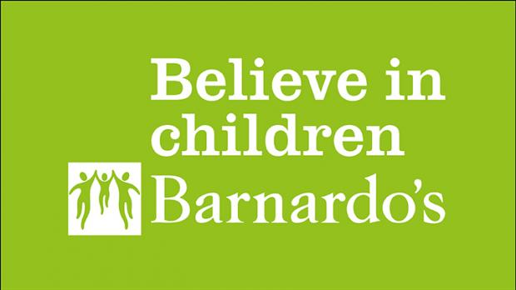

We protect, support, and nurture the UK's most vulnerable children. We help children through the trauma of sexual abuse and exploitation.

We provide support for young people in care – and we don’t forget about them when they leave the care system.

We give children caring for a loved one the help and support they deserve.

And that’s not all. Our specialist workers support families through domestic abuse, mental health problems, prison sentences, asylum seeking and much more.

We also amplify the voices of young people to influence Government on the issues that affect their lives, fighting their corner and making sure their voices are heard.

The scale of what we do may be big and complex, but our aim is simple – to provide the best outcome for every child, no matter who they are or what they have been through. <https://www.barnardos.org.uk/>

**A registered charity run by and for families of children and young people (aged 0-25) who have Special Educational Needs and/or Disabilities (SEND)**

**We work in partnership with service commissioners and providers, sharing knowledge and experience of families to help plan and develop the quality, range, and accessibility of provision, creating better outcomes for families through participation and co-production.**

**131 Green Lane, Rawmarsh,**

**Rotherham**

**South Yorkshire**

**S62 6JY**

**Telephone: 01709 296262**

**Email:** [**info@rpcf.co.uk**](mailto:info@rpcf.co.uk)

**Website:** [**www.rpcf.co.uk**](http://www.rpcf.co.uk)

**Better Health**

**Food Scanner App Campaign**

**The new childhood nutrition campaign launched on the 10th of January 2022 and focuses on using the Food Scanner app to help families make healthier food and drink swaps. This app can be downloaded from:** [**Apple app store**](https://apps.apple.com/app/apple-store/id1182946415?pt=117868640&ct=FS_CRC&mt=8)

[**Google Play store**](Google%20Play%20store)

**Don't live in the past**

**don't worry about the future**

**live for today in the present moment**

Mindfulness in Sheffield are qualified Breathworks Tutors having several health and wellbeing [programmes](https://www.mindfulnessinsheffield.co.uk/mindfulness-programmes-1) to suit all. We will help you understand and come to terms with your pain, stress, anxieties, and depression. You too could benefit from mindfulness practices and techniques.

Every other Thursday at **Heaven is Homemade Tea rooms** Todwick, 5pm for 1hr. Free drink (non-alcoholic). £5 per person.

Mindfulness in Sheffield

Minera House,

9A School Road

Beighton

Sheffield

S20 1EG

P: 07458656564

E: [tony@mindfulnessinsheffield.co.uk](mailto:tony@mindfulnessinsheffield.co.uk)

W: [www.mindfulnessinsheffield.co.uk](http://www.mindfulnessinsheffield.co.uk)

FB: @sheffieldhealthandwellbeing